Introduction

The current of each switchable power output must be measured.
Accuracy requirement: 1% of maximum - ± 150mA.

Key component selection
MCS1802GS-20-Z from Monolithic Power Systems will be used.
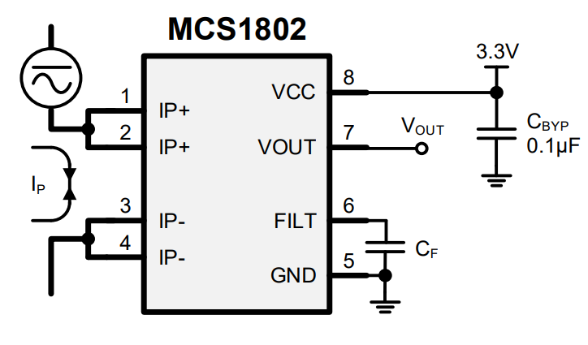
Figure 1: Typical application of MCS102 series

It works from 3,3V supply and the model with -20 suffix is optimized for 20A current range.
Pins 5-8 are isolated from pins 1-4 up to 2200Vrms (60 seconds)
The sensitivity is 66mV/A. The output is proportional to the current measured.

Unfortunately, in the datasheet the maximum short-circuit or instantaneous current is not stated. The same chip has variants that can measure up to 50A and this knowledge is used at the moment. But it’s critical that fault tolerance is checked experimentally. The fuse must break before the sensor.

Test was performed with EVCS1802-S-20-00A evaluation kit for MCS1802. Current was measured at 2-3A intervals from 0A-15A.

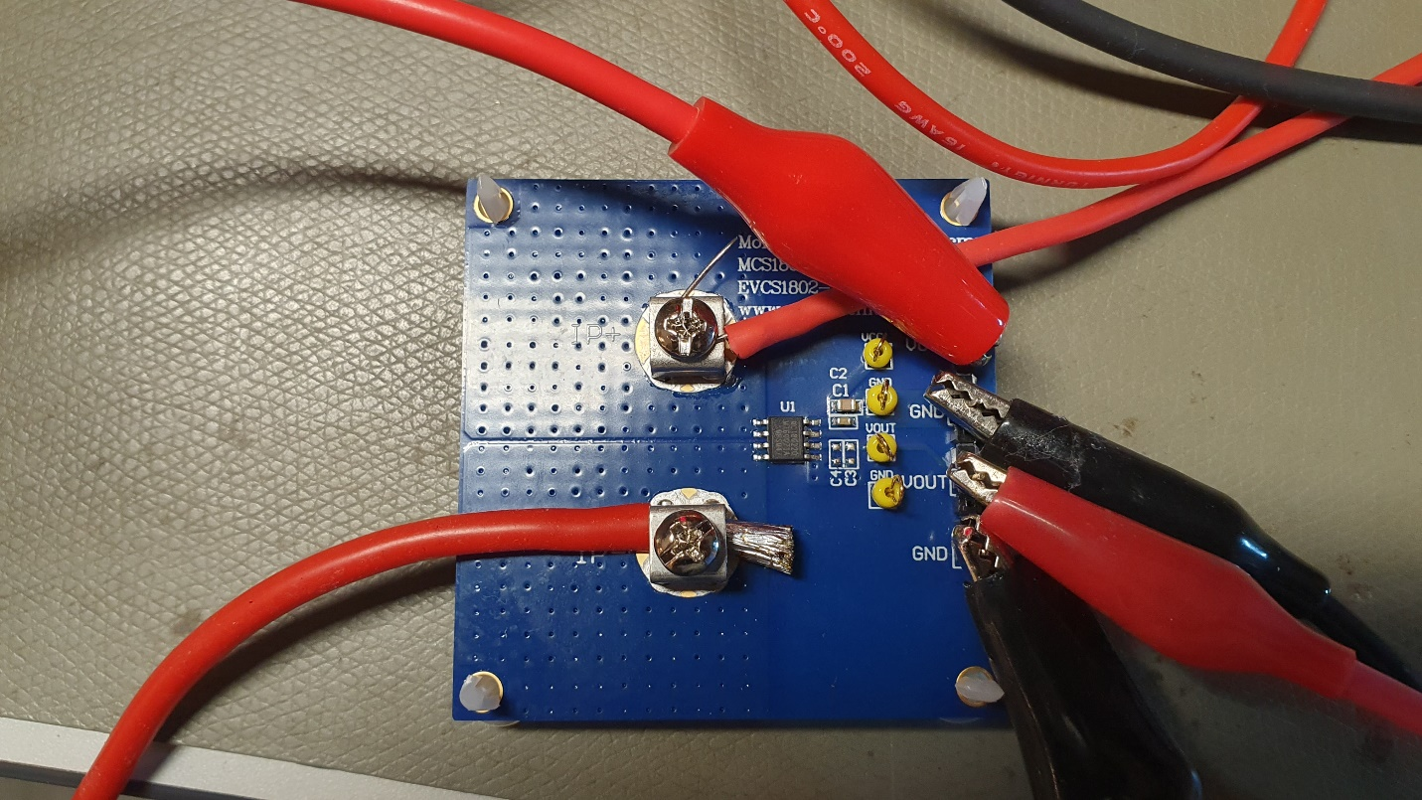
Current was generated with power supply and slinked by electronic load that also selected the test current.
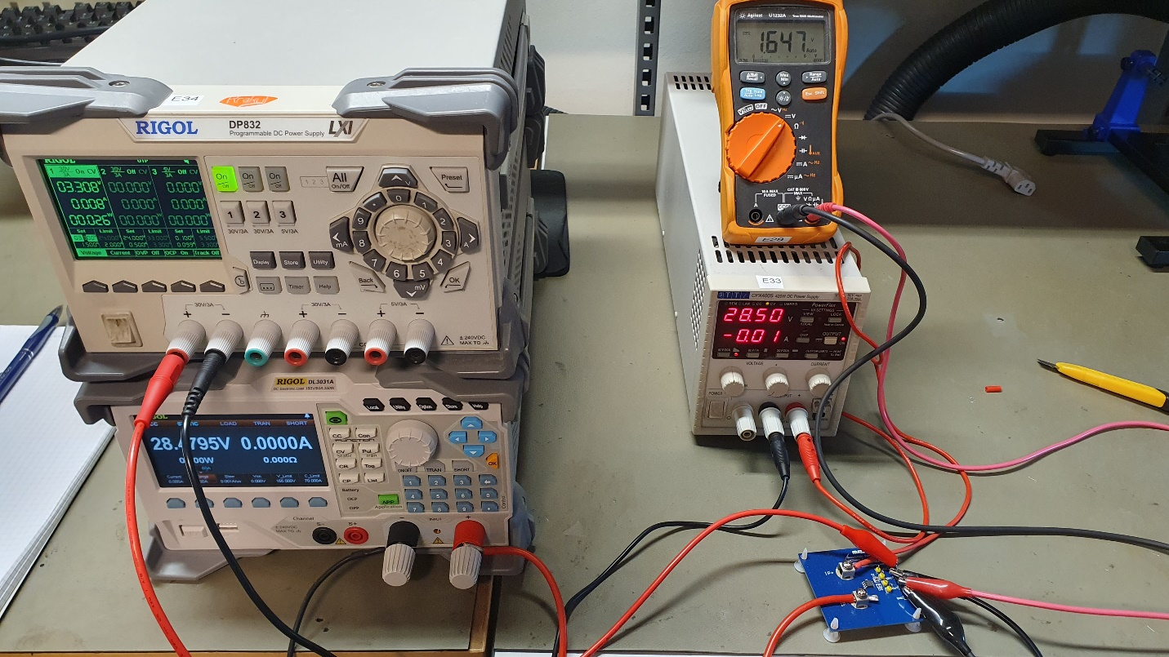
The current measurement IC was powered by another power supply with 3,3V. The 0 current output voltage of the IC is 1.647V or half the supply voltage. This is due to the fact that the sensor is bidirectional.
All measurements were performed at 28.5V except the last one. The 15A load was measured at 24V due to the 350W power limitation of the electronic load.
Current [A] | Voltage [V]
0 | 1,647
1 | 1,713
3 | 1,846
5 | 1,978
7 | 2,111
10 | 2,311
12 | 2,444
15 | 2,643
IC temperature at the beginning of test – 23.4 °C.
IC temperature at the end of test – 30.6 °C. 15A load was held for several minutes. IR camera detected greater temperature rise in cables than in the IC.
The heating is roughly in line with what the datasheet states.
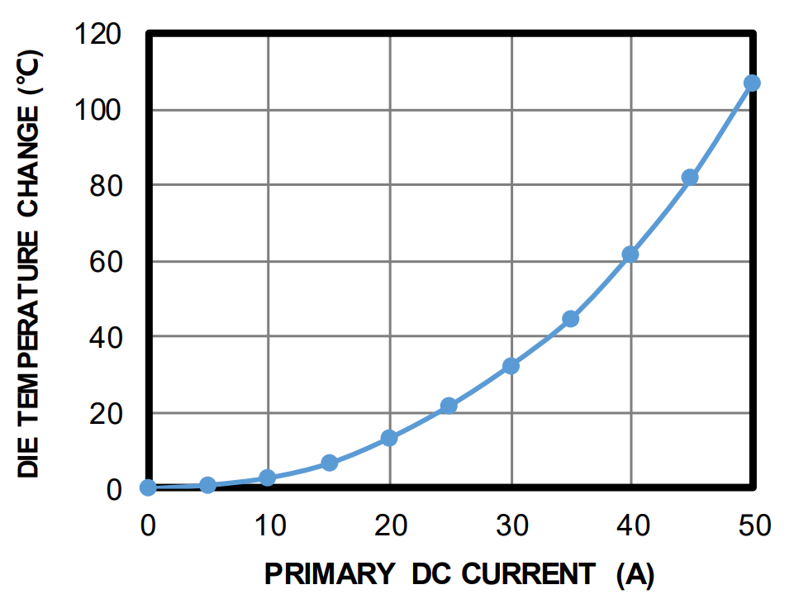
Typical application circuit suggests 1uF bypass capacitor for the input.
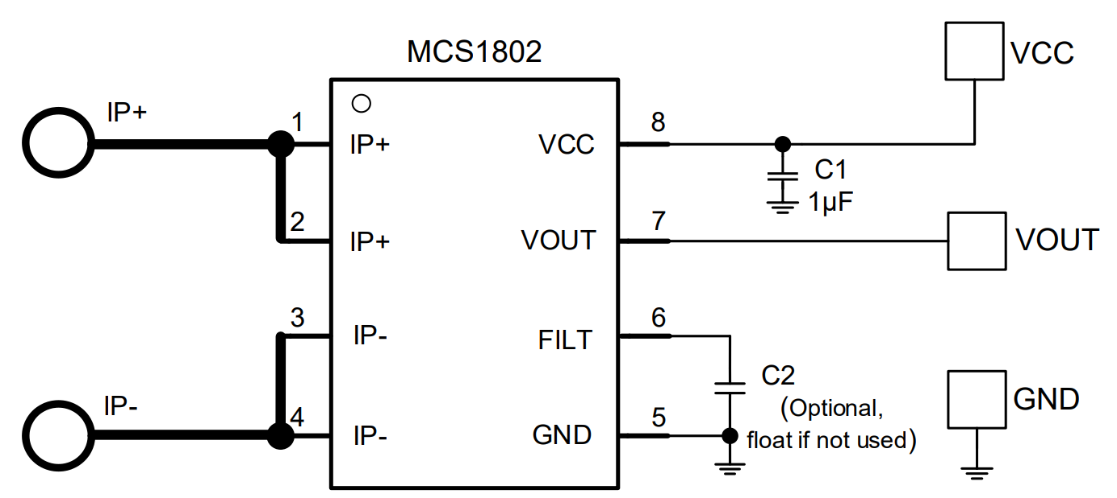
FILT pin is for external capacitor. The capacitor is optional, and it can be used to decrease the pass-band of the internal low pass filter.
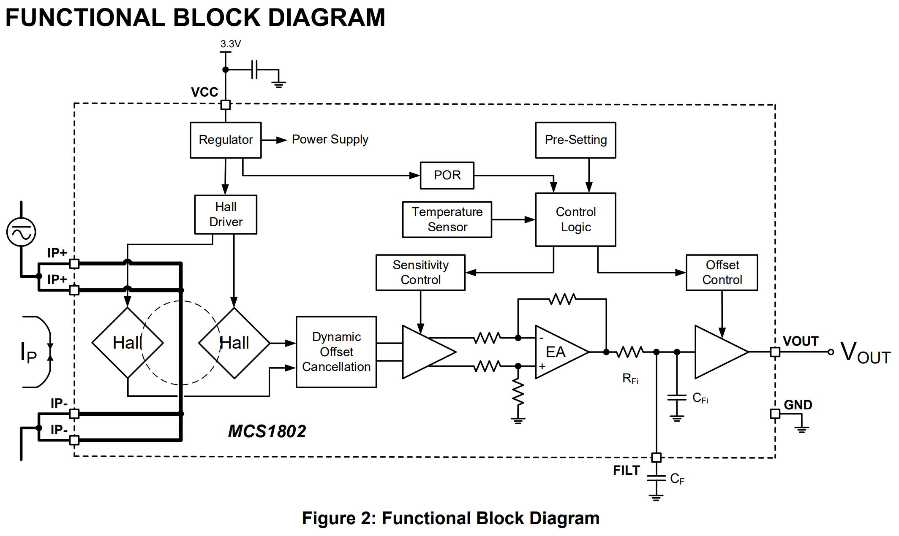
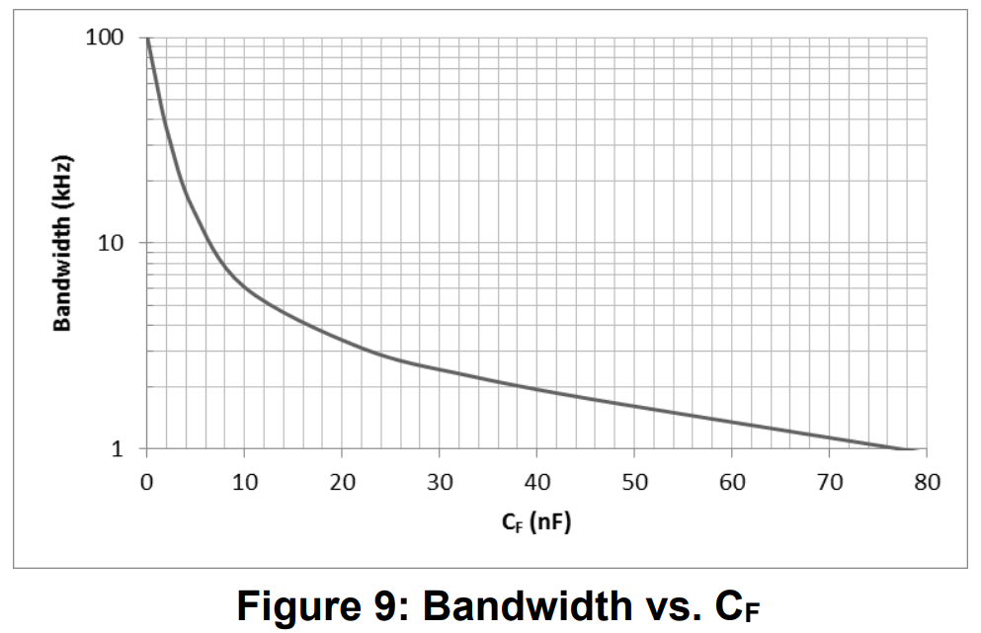

10nF capacitor will give the cutoff at 6kHz. This should allow for a slower sampling rate and less averaging. An additional 0,1uF capacitor shall be placed at the VOUT pin to reduce the ADC sampling effects.

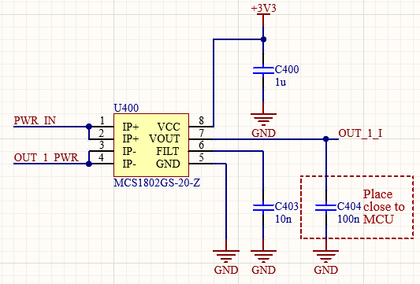
Figure 2: Implemented schematic.

